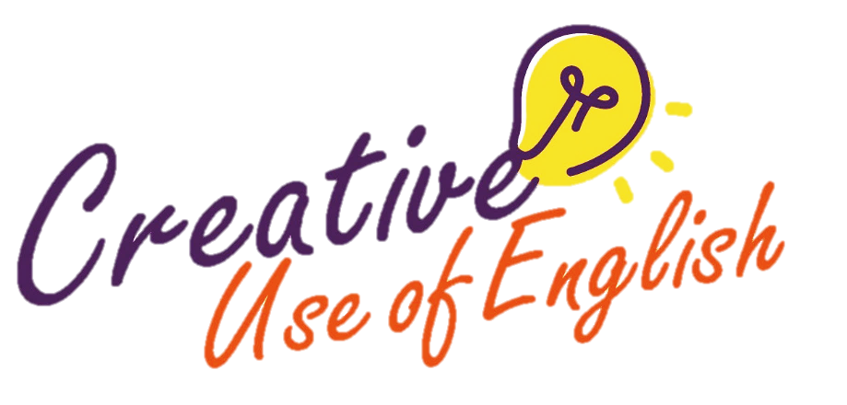

Curriculum Development Institute

Education Bureau HKSAR ©2022

Prepositional phrases

|  |
| --- |
| 3. Use  to describe actions |
| *Add prepositional phrases to the underlined action verbs to provide further details about the feelings of the characters and the manner of the actions.* |
| When the finish line was in sight, the hare  and the tortoise could hear the crowd **squealing** . The cheering was heartening and the hare and the tortoise **pressed** **ahead** . When they finally crossed the finish line, the tortoise couldn’t believe his eyes. He **asked** the hare  , “Am I daydreaming? Have we won the race?” The hare **answered**  , “Of course, we have!” They then hugged each other and **capered**  **.** |

WITH fear, joy, sadness, delight, pride, excitement, respect, gratitude, disappointment, relief, hesitation, ease, difficulty, all might, certainty

IN anger, surprise, dismay, frustration, shock, regret, pain, grief, terror, doubt

OUT OF curiousity, jealousy, spite, fear, guilt

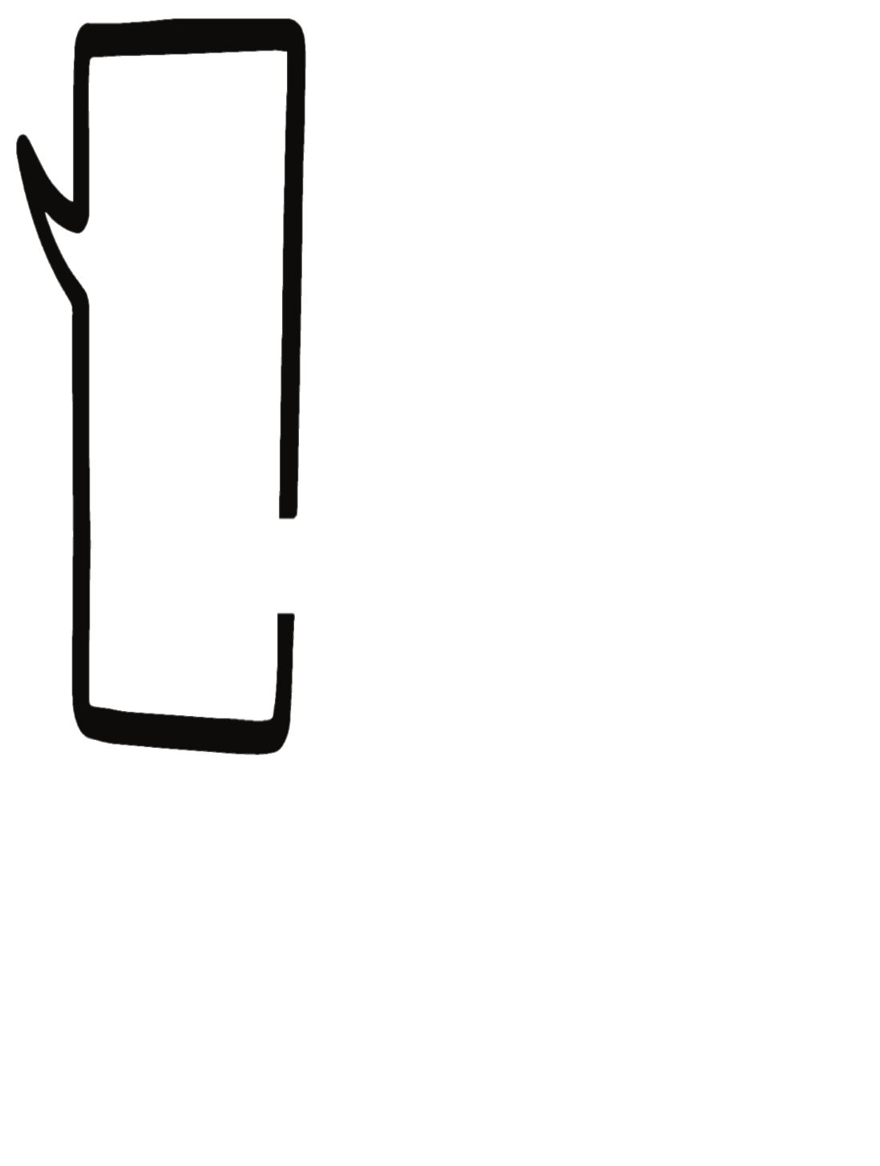

Use these three strategies in combination to enliven the character(s) in action.

|  |
| --- |
| *1. Use to add flavour & express more ideas in fewer words* |
| *Replace the* ***underlined words*** *below with* ***vivid verbs****.* |
| The hare saw a noisy crowd gathering around the tree. He **went quickly** to the tree to find out what was going on. The animals were talking  excitedly about the poster on the trunk. He **read**  **carefully**  the words on the poster and learnt that an obstacle pair race would be held soon. The hare **said softly** to himself, “I must find the best partner and win the grand prize!” He **looked steadily**  at the wide blue sky and started **thinking deeply about**  who  to team up with. |

Vivid verbs

**Topic**



Different Ways to Describe Actions

***2. Use to   
describe actions***

Adverbs

**In the tale *The Tortoise and the Hare*, two animals challenge each other to a race to prove who is the fastest. Mid-race, the hare lies down to rest, certain that it will win. The tortoise, though slow, never gives up and crosses the finishing line ahead of the hare. Slow and steady wins the race, as the message of the story goes.**

* Re-write this story.
* Use the same characters but imagine that the tortoise and the hare team up to race against other contestants.
* Express a message through the telling of the story.
* Give your story a title.

*Writing topic taken from Paper 2 of the 2019 HKDSE English Language Examination © HKEAA*

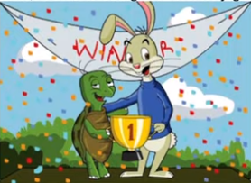

|  |
| --- |
|  |
| *Add* ***adverbs*** *to the underlined action verbs to describe the mood of the characters and the manner of the actions.* |
| The obstacle race was a tough one – all the tougher for a slow and small tortoise! While the hare could  **jump**  over the log hurdle, the tortoise could only **crawl** under it and had to be lifted by the hare. When they came to the monkey bars, the tortoise **frowned and sighed**  as he knew he could never get through. The hare **said** to his partner, “Get onto my back!” Then, he d **moved** across the bars, making sure that the tortoise wouldn’t fall off. After climbing the monkey bars, the hare **was panting** . |

MOOD: excitedly, warmly, confidently, eagerly, seriously, furiously, worriedly, hopelessly, thankfully, impatiently, relunctantly, wearily

MANNER: effortlessly, strenuously, breathlessly, swiftly, slowly, softly, loudly, gently, hard, abruptly